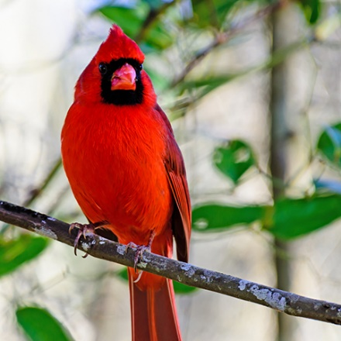  Northern Cardinal  Cardinalis cardinalis  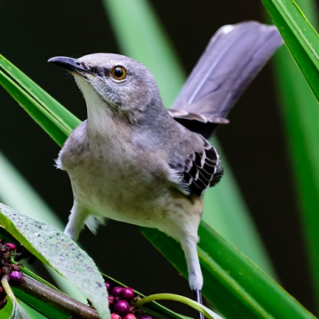  Northern Mockingbird  Mimus polyglottos  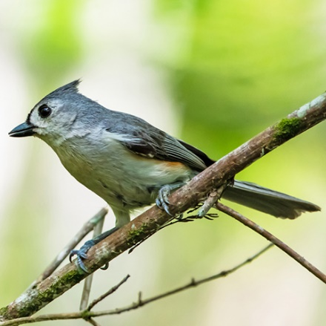  Tufted Titmouse  Baeolophus bicolor  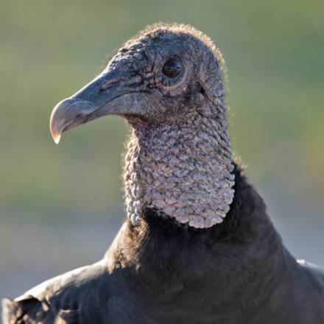  Black Vulture  Coragyps atratus  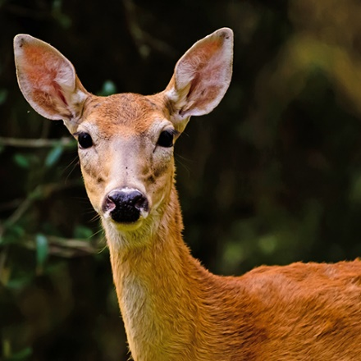  White-tailed Deer  Odocoileus virginianus  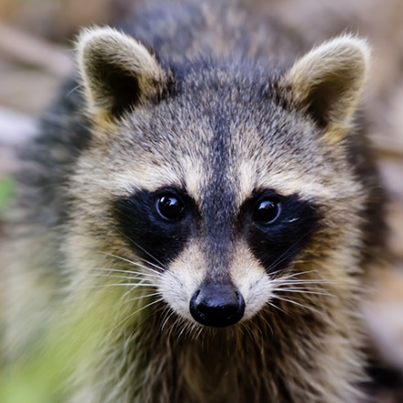  Raccoon  Procyon lotor  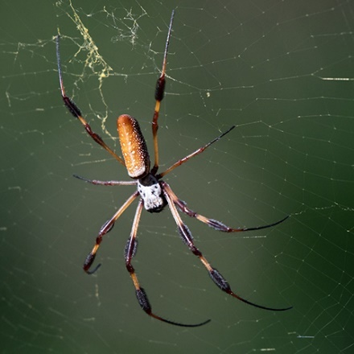  Golden Silk Orbweaver  Nephila  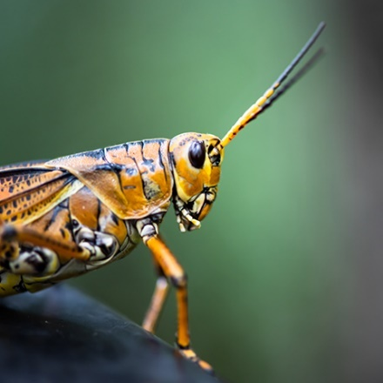  Eastern Lubber Grasshopper  Leucauge venusta  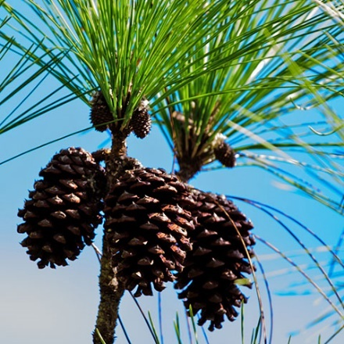  Pinecones (South Florida Slash Pine)  Pinus elliottii  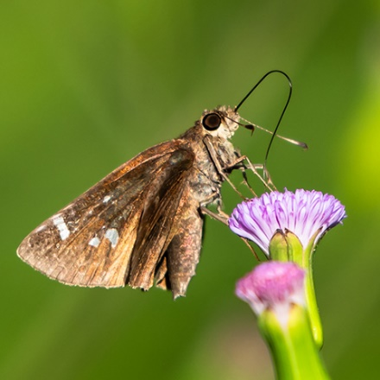  Clouded Skipper  Lerema accius  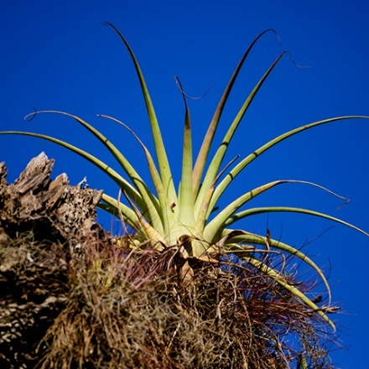  Giant Airplant  Tillandsia fasciculata  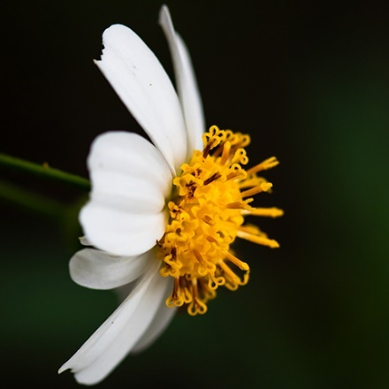  Beggarstick  Bidens alba | 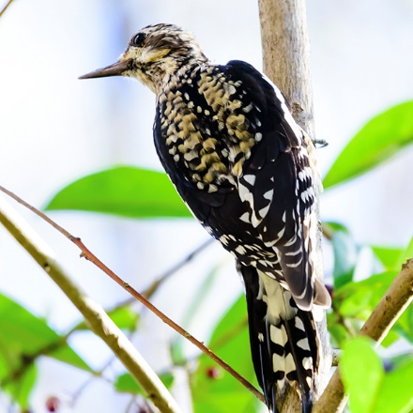  Yellow-bellied Sapsucker  Sphyrapicus varius  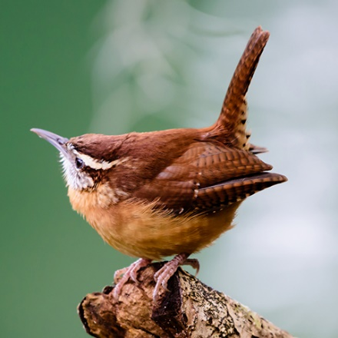  Carolina Wren  Thryothorus ludovicianus  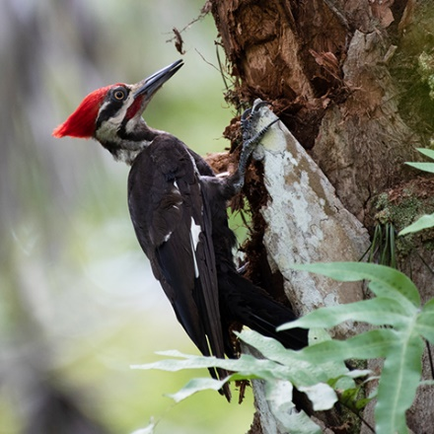  Pileated Woodpecker  Dryocopus pileatus  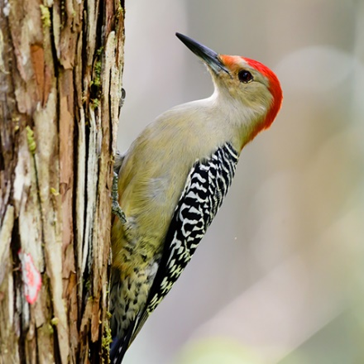  Red-bellied Woodpecker  Melanerpes carolinus  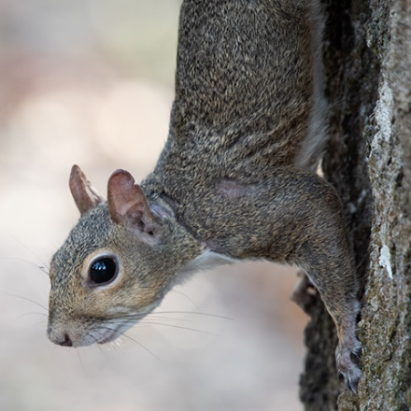  Eastern Gray Squirrel  Sciurus carolinensis  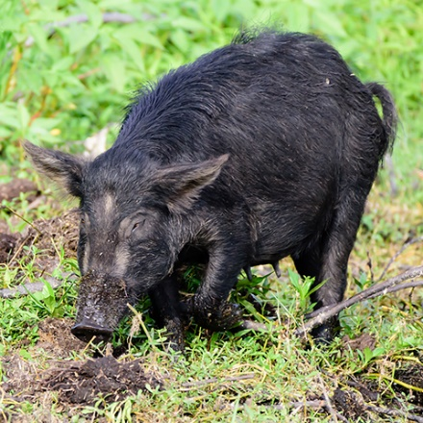  Wild Hog  Sus scrofa  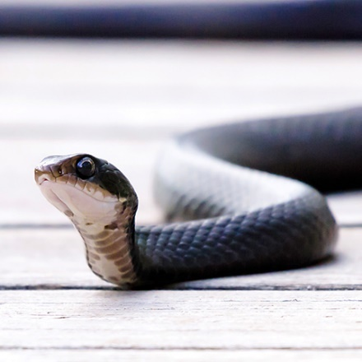  Southern Black Racer  Coluber constrictor priapus  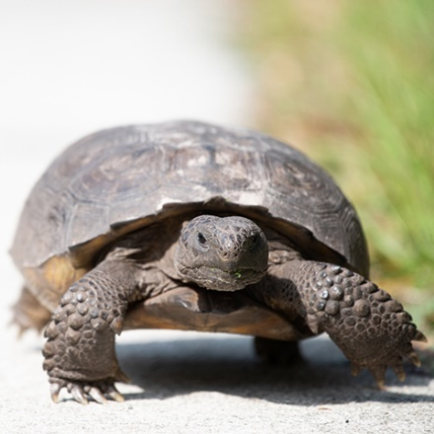  Gopher Tortoise  Gopherus polyphemus  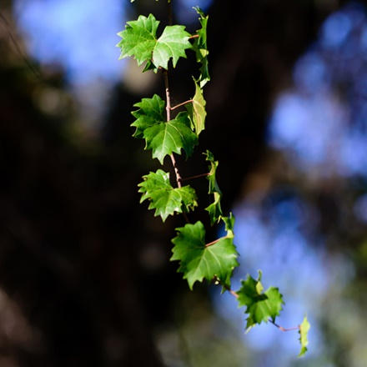  Muscadine Grape  Vitis rotundifolia  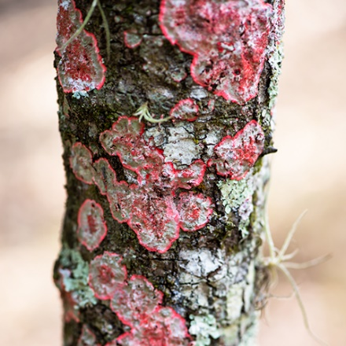  Christmas Lichen  Cryptothecia rubrocincta  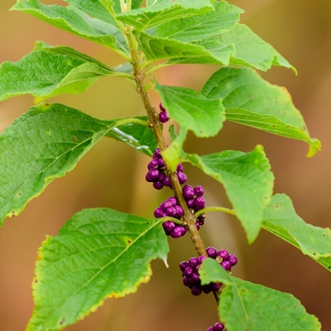  American Beautyberry  Callicarpa americana  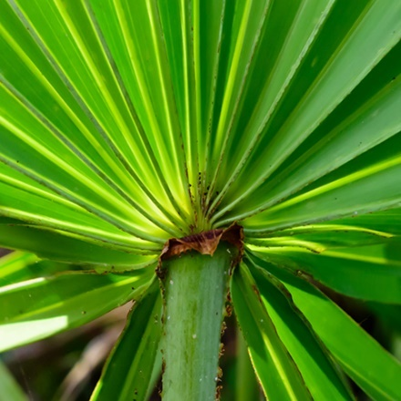  Saw Palmetto  Serenoa repens | 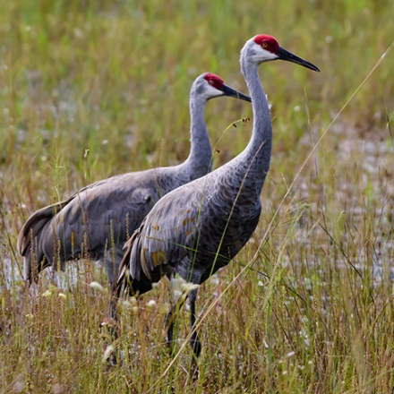  Sandhill Cranes  Antigone canadesis  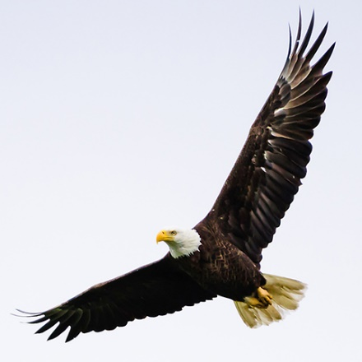  Bald Eagle  Haliaeetus leucocephalus  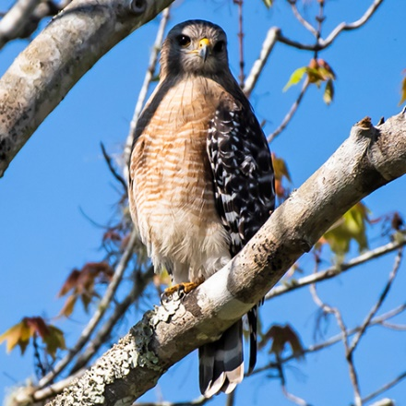  Red-shouldered Hawk  Buteo lineatus  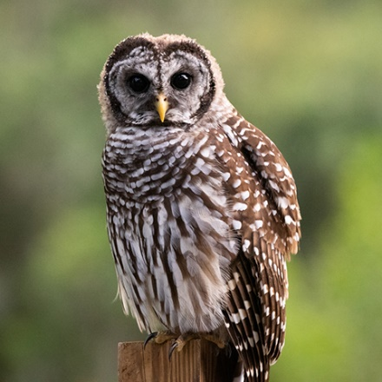  Barred Owl  Strix varia  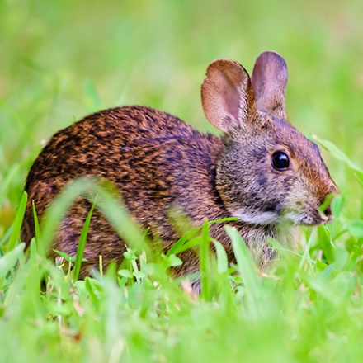  Marsh Rabbit  Sylvilagus palustris  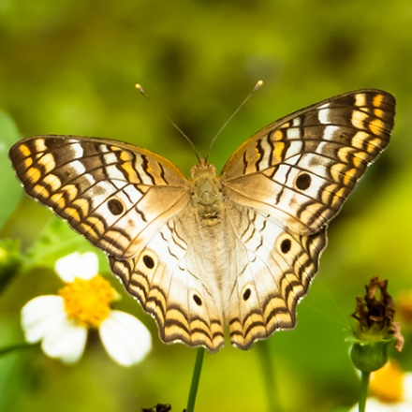  White Peacock Butterfly  Anartia jatrophae  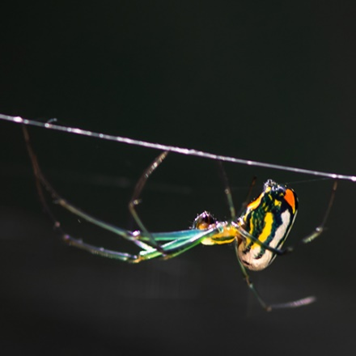  Orchard Orb Weaver  Leucauge venusta  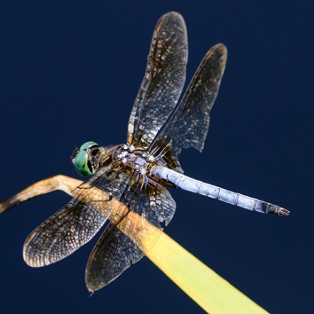  Blue Dasher Dragonfly  Pachydiplax longipennis  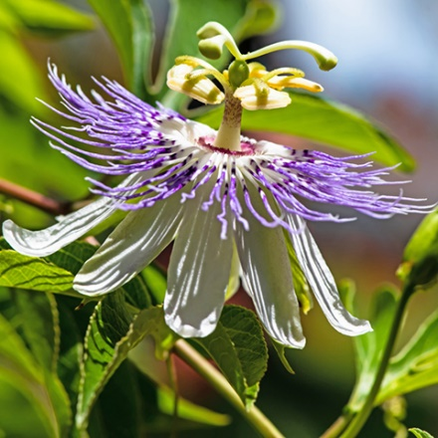  Purple Passionflower  Passiflora incarnata  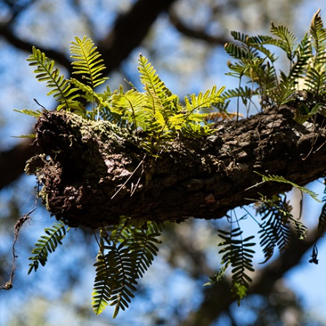  Resurrection Fern  Pleopeltis polypodioides  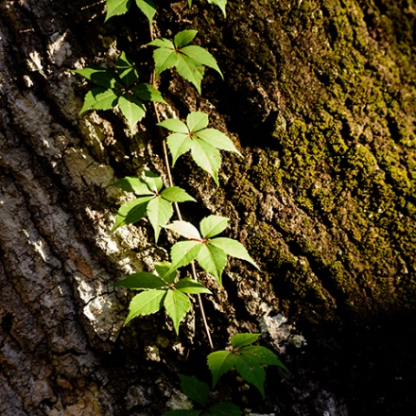  Virginia Creeper  Parthenocissus quinquefolia  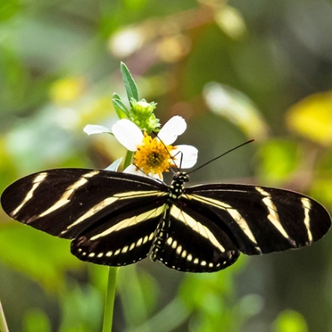  Zebra Longwing Butterfly  Heliconius charithonia

Uplands Scavenger Hunt
Look up, down, and all around for the plants and animals on these pages. Either put an X on each item as you find it, or take a photo of your own to share. Try to remember the names of everything you find.

Please explore nature responsibly.
- Leave no trace, take all trash and food scraps with you when you leave.
- Take only photos and leave everything else where you found it.
- Never feed a wild animal or entice them with food.
- Keep a safe distance from all animals and don’t scare or disturb them.
- Stay on the trails and avoid stepping on plants.
- Share your love of nature and teach others whenever you get a chance.

"In the end we will conserve only what we love; we will love only what we understand; and we will understand only what we are taught."
- Baba Dioum, 1968.

Photos courtesy of Robin Hagan (RH Photo Adventures)

